 | Weekly Review Test Jan. 2012 1/23-1/31
 | Week 4 (pp. 50-66) Advanced Level
Class:____________________________ No.:____________ Name:______________________________

Section One: Listening Comprehension
Part 1. Picture Questions (6%)
Look at each picture and answer the question.

For questions number 1 and 2, please look at picture A.
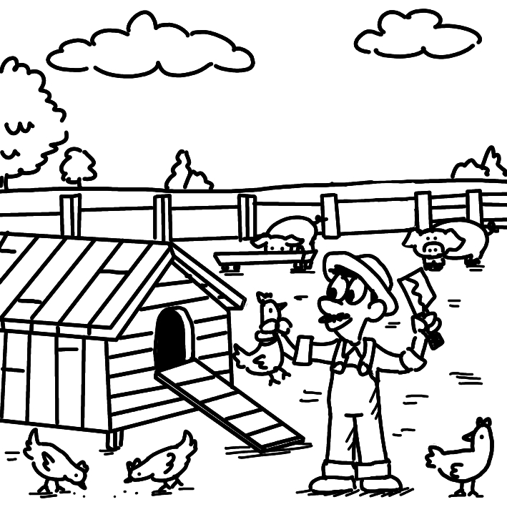
A.

(C) 1. What is TRUE about the picture? (p. 60)
(A) The animals are being wiped out.
(B) The animals are escaping from the place.
(C) The man raises livestock.
(D) The man is holding a panel.

(A) 2. What can we say about the man? (p. 60)
(A) He is going to prepare poultry.
(B) He is picking up cleaning supplies.
(C) He is being disturbed by the animals.
(D) He has a luxurious life.

For question number 3, please look at picture B.

B.

(B) 3. What do we know about the woman? (p. 56)
(A) She is getting rid of an object.
(B) She is making a mold.
(C) She is being kidnapped.
(D) She is using fossil fuel.

Part 2. Best Response Questions (20%)
Listen to the question or statement and choose the best response.

(C) 4. What is Joseph doing to compensate for his
bad grades? (p. 60)
(A) His parents will give him money to pay
for them.
(B) Nobody is telling him to do it on
purpose.
(C) He hopes a well-done report will help.
(D) I don’t know why he doesn’t get better
grades.

(D) 5. Our samples became contaminated with
those from another lab. (p. 60)
(A) Yeah. Our results matched those of the
other lab.
(B) Good. Now we know where our samples
are.
(C) True. All the samples have passed the
tests.
(D) You’re right. Someone mixed them
together.

(A) 6. Certain animals have skin that is resistant to
water. (p. 60)
(A) Yeah. Because of this, they never stay
wet.
(B) Yes. Their bodies keep water on the
skin.
(C) Right. They are actually very sensitive to
it.
(D) True. So their skin needs extra water.

(B) 7. In California, the consumption of horses is
against the law. (p. 60)
(A) Yeah, they can’t be bought and sold
there.
(B) No, you can still eat them in that state.
(C) Yes, it is illegal to hunt them in the wild.
(D) No, I see horse races there all the time.

(B) 8. The friction is making it hard to push this
box along the ground. (p. 56)
(A) I know. The rain has made it hard to
control it.
(B) You’re right. The road isn’t very smooth.
(C) Yeah. We should move the other boxes
out of the way.
(D) Yes. The box is too heavy. Even a strong
man couldn’t move it.

Part 3. Conversation Questions (12%)
Listen to each conversation and answer the question.

(D) 9. F: Good evening. What would you like to
start off with? (p. 56)
M: I’d like a salad. I would also like a glass
of wine.
F: Very good. What would you like for
your main course?
M: The duck dish sounds nice. I’ll go with
that.
F: Sorry, but we’re all out at the moment.
M: All right. Let me think of an alternative,
then.
Q: What is the man going to do?
(A) Cook the duck himself.
(B) Talk to the head chef.
(C) Go to another restaurant.
(D) Choose a different dish.

(C) 10. M: I’m going on a trip to the countryside
this weekend. (p. 56)
F: Are you riding in a friend’s car or
driving your own?
M: Neither. I’ll be renting a scooter and
riding there myself.
F: I’ve always wanted to learn how to ride
a scooter.
M: It’s simple. Stability is the most
important part of it.
F: Maybe I can go with you and practice
on the open road.
Q: What does the man say is important
about riding a scooter?
(A) Keeping your eyes on the road.
(B) Knowing all the traffic laws.
(C) Maintaining your balance.
(D) Not going too slow or too fast.

(A) 11. F: Let’s finish our breakfast and get going.
We have a long day. (p. 56)
M: I’m almost done. We’ll have to wait for
William, though.
F: I don’t see him. Is he still in the hotel
room?
M: Yeah. He woke up about thirty minutes
after we did.
F: Does he always take so long to get out
of bed?
M: It’s pretty much the norm when we go
on vacations.
Q: What does the man say about William?
(A) He usually sleeps later during trips.
(B) He rarely oversleeps.
(C) He always wakes up early.
(D) He is sometimes the quickest out of
bed.

Part 4. Short Talk (9%)
Listen to the passage and answer the questions.

Antibiotics were first introduced to farm animals’ diets in the mid-1940s. They were effective in not only combating disease, but also allowing livestock to grow faster and put on more weight. Focused on making more money, farm owners started using antibiotics for entire farms and even on healthy animals. The problem with this widespread use was that it was impossible to wipe out 100% of the bacteria. Anything that survived grew stronger. This lead to strains of “superbugs” that evolved and became drug-resistant. Humans eating meat from infected animals could become sick. Further, farm workers who came into contact with these animals could be affected as well. Today, many farmers are leaving out antibiotics from their animals’ diets in response to people avoiding such products at the supermarket.

(B) 12. What did antibiotics do to farm animals?
(A) Made them cheaper to raise.
(B) Made them grow bigger.
(C) Made them eat less.
(D) Made them weaker against bugs.

(B) 13. Why was antibiotic use a problem?
(A) It made the animals overweight.
(B) It could not completely kill off bacteria.
(C) It was too expensive to use repeatedly.
(D) It made the animals sick sometimes.

(C) 14. What is the current trend of antibiotic use?
(A) Farmers are using about the same
amount.
(B) Farmers are using more than ever.
(C) Farmers are using less now.
(D) Farmers are using different kinds.

Section Two: Reading Comprehension
一、詞彙 (15%)

(A) 1. The supervisor was ____ in his inspection of
the employee’s work. (p. 51)
(A) thorough (B) fossil
(C) unsanitary (D) leftover

(C) 2. Patrick apologized. More importantly, he
tried to ____ for his mistake. (p. 60)
(A) hail (B) evolve
(C) compensate (D) translate

(B) 3. If it’s too cold, you can ____ the air
conditioner and make it warmer. (p. 65)
(A) disturb (B) adjust
(C) overuse (D) symbolize

(D) 4. The water in the lake is now ____, causing
the fish in it to die. (p. 60)
(A) accused (B) refueled
(C) emitted (D) contaminated

(D) 5. The researchers analyzed each individual
____ of the drug. (p. 56)
(A) consequence (B) strain
(C) retrospect (D) component

二、文意選填 (14%)

Horizon Yacht of Taiwan and SolarWaterWorld of Germany have come out with a new type of yacht. Running solely on solar power, it __(6)__ a welcome alternative to the typical fossil fuel-burning vessels. The __(7)__ boat is called Suncat 46. The two companies hope that this kind of ship can become the new __(8)__, helping the industry take a positive step toward a cleaner environment.

Construction of the 20-ton vehicle was not easy. Designers decided on twin hulls, or frames, for the boat body to minimize __(9)__ and add stability. With many solar panels __(10)__ the roof, maintaining balance was an important consideration. Placement of the panels was also a challenge. The need for so many of them meant that the Suncat 46 lacked visual __(11)__. Thus, designers created three separate __(12)__ that joined together to form the vessel. It made the luxury vessel look more like a boat and less like a bus.

(A) attached to (B) norm (C) eco-friendly
(D) friction (E) serves as
(F) molds (G) appeal

Answer: 6. (E) 7. (C) 8. (B) 9. (D)
10. (A) 11. (G) 12. (F)

三、閱讀測驗 (9%)

Humans need animals to survive. Not just those that provide food and companionship, but also the ones that people normally avoid. Recent medical breakthroughs have produced evidence on the potential life-saving capabilities of many creatures, including those that are normally considered dangerous to humans.

Not many people like spiders, but they can do more for humans than simply killing other insects. The silk web material from the banana spider has shown the ability to assist in the growth of skin cells. As opposed to silkworm silk, the human body isn’t resistant to the spider’s silk. Therefore, scientists believe it can be used for burn victims and other people that need artificial skin. The hobo spider, found in Europe and the U.S. Pacific Northwest, is feared for its painful bite. The venom contained in the bite can kill human tissue and flesh. However, according to scientists, a neurotoxin found in the venom could possibly be used to treat nervous system disorders such as chronic pain. Venom from another small bug is being looked into for cancer treatment. The deathstalker scorpion’s venom also contains a neurotoxin called chlorotoxin, which scientists say is more effective at killing brain tumors than any other alternative.

(A) 13. What is the main idea of the passage?
(A) Humans can look to creatures for
medical inspiration.
(B) Creatures considered dangerous are
actually safe.
(C) Spiders can come in various species.
(D) Creatures cannot be judged by their
appearances.

(B) 14. How many examples of research into
potential life-saving creatures are given?
(A) Two.
(B) Three.
(C) Four.
(D) Five.

(B) 15. What pair of bugs and their medical uses is
NOT correct?
(A) the banana spider’s silk: assisting in
growing skin cells
(B) the silkworm’s silk: used for burn
victims
(C) the hobo spider’s venom: treating
chronic pain
(D) the deathstalker scorpion’s venom:
killing brain tumors

四、中譯英 (12%)

16. 漢克雖然是個能幹的人，但因為傲慢，沒人
想跟他合作。(p. 57)
Though Hank is an able man, nobody wants to
team up with him because of his arrogance.

17. 我姑姑每天上健身房健身，以免體重增加。
(p. 61)
My aunt works out in the gym every day so as
not to put on weight.

18. 抱歉佔用你這麼多時間，謝謝你的體諒。
(p. 57)
Sorry for taking up so much of your time.
Thanks for your consideration.

