 | Weekly Review Test Jan. 2012 1/16-1/20
 | Week 3 (pp. 38-49) Advanced Level
Class:____________________________ No.:____________ Name:______________________________

Section One: Listening Comprehension
Part 1. Picture Questions (6%)
Look at each picture and answer the question.

For questions number 1 and 2, please look at picture A.
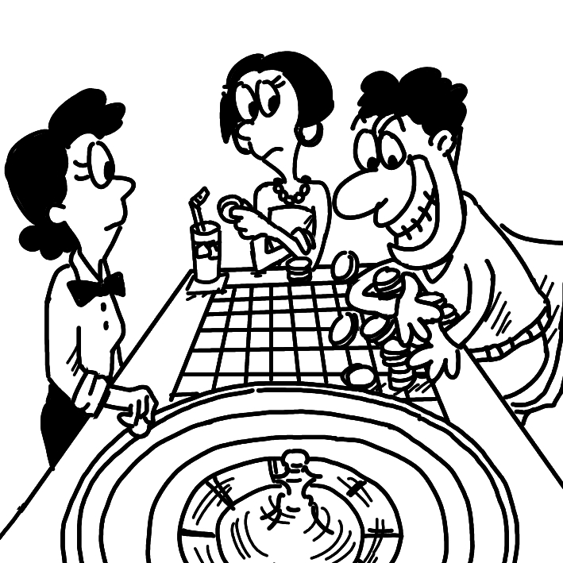
A.

(A) 1. What do we know about the people? (p. 43)
(A) They are inside a casino.
(B) They are exploring the room.
(C) They are members of a senate.
(D) They are collapsing on the table.

(D) 2. What is TRUE about the man? (p. 48)
(A) He is sitting in a fortress.
(B) He is in possession of cards.
(C) He is dressed in elegant clothes.
(D) He is showing his greed.

For question number 3, please look at picture B.

B.

(D) 3. What is the boy doing? (p. 48)
(A) He is roaming around.
(B) He is absorbing water.
(C) He is trekking in the area.
(D) He is devouring the food.

Part 2. Best Response Questions (20%)
Listen to the question or statement and choose the best response.

(C) 4. Larry struck it rich betting on the stock
market. (p. 47)
(A) That’s true. He lost a fortune on his
gambling.
(B) Yeah. He has met lots of rich people
through it.
(C) I know. He got lucky and made a ton of
money.
(D) I agree. It has been a big waste of time.

(A) 5. There are many sprawling cities all across
China today. (p. 47)
(A) Yeah. They are growing wildly at a fast
speed.
(B) You’re right. They are all very empty.
(C) Yes. Getting enough food isn’t a
problem for them.
(D) That’s true. Everyone is moving out of
them.

(D) 6. My cousin says that he has an authentic
baseball from the game. (p. 47)
(A) Yes. He knows that it’s a fake.
(B) I know. He only has a picture of it.
(C) Yeah. It’s just a smaller version of the
ball.
(D) Wow! Was it really played in the game?

(A) 7. My requirement for my new bed is that it
must be cozy. (p. 47)
(A) Sure. We have several comfortable beds
to choose from.
(B) All right. I understand that you are on a
budget.
(C) Of course. All the name brand beds are
over here.
(D) OK. This is the biggest bed that we have.

(C) 8. The country’s heritage is something that
must never be lost. (p. 43)
(A) Yeah. They are trying to prevent job
losses.
(B) Right. A person that gets into trouble
should be helped.
(C) Yes. Their traditions and way of life
have been around for ages.
(D) Agreed. Money is the key to their status
in the world.

Part 3. Conversation Questions (12%)
Listen to each conversation and answer the question.

(A) 9. F: Don’t go to bed too late tonight. We
need to wake up early. (p. 40)
M: All right. What are we doing first
tomorrow?
F: There’s a museum that I’ve always
wanted to visit.
M: Fine. Do you know how to get there?
F: We’ll have to trek from our hotel.
M: Great. I hope I’ll have time for breakfast,
at least.
Q: How are the man and woman going to
the museum?
(A) They will have to walk.
(B) They are taking a taxi.
(C) They can wait for the bus.
(D) They will ride the subway.

(B) 10. F: We have a guest speaker today in class.
M: I like when we have those. Who is it
this time? (p. 45)
F: I don’t know exactly. He works for the
senate.
M: That sounds pretty boring.
F: You never know. We’ve never had
someone like him before.
M: You’re right. Hopefully we’ll still learn
something.
Q: What do we know about the guest
speaker?
(A) He is a successful businessman.
(B) He works in government.
(C) He is a famous movie star.
(D) He is a teacher from another class.

(B) 11. F: I’m visiting the countryside over the
break. (p. 45)
M: There are lots of things to see there.
F: Yeah. The green grass and hills will be
a breath of fresh air.
M: I recommend checking out the lake. It’s
nice and quiet.
F: How do I get there? I will be taking my
bike.
M: Go on the main road until you see an
old fortress. It’s close by.
Q: What does the woman need to look for?
(A) A farm with many animals.
(B) A large castle-like building.
(C) A market with people selling things.
(D) A hill with fields of grass.

Part 4. Short Talk (9%)
Listen to the passage and answer the questions.

Although Macau is known for its gambling today, there is still a lot of culture and history to be found. Many of the churches used to serve a special purpose. For example, St. Lazarus’s Church was home to sick people in the past. Today, it has been converted into an art center. On top of Guia Hill is an elegant chapel that has typical 19th century European architecture. Nearby is a lighthouse that used to provide guidance for sailors when Macau was a bustling trading port. Today, the lighthouse overlooks sprawling casinos and hotels. As a region heavily dependent on tourism, food can be expensive in Macau. Fortunately, there are places with delicious cheap food. Great examples of this are the authentic Portuguese restaurants.

(C) 12. What is TRUE about St. Lazarus’s Church?
(A) It has become a casino.
(B) It was changed into a hotel.
(C) It is now an art center.
(D) It is a home for the sick.

(B) 13. What is the likely reason a lighthouse was
built on the hill?
(A) To create a place where the homeless
could stay.
(B) To help ships find their way through
the waters.
(C) To have a second church for people to
go to.
(D) To provide more gambling business for
the region.

(B) 14. Why does the speaker say food is
expensive in Macau?
(A) A lot of it is Portuguese.
(B) Tourism is the major industry.
(C) It has to come from out of the country.
(D) There are few good restaurants.

Section Two: Reading Comprehension
一、詞彙 (15%)

(D) 1. Pay attention to the building’s escape ____
in case of fire. (p. 40)
(A) quarters (B) barracks
(C) fortresses (D) routes

(A) 2. To get water, the locals have to ____ two
miles to the nearest well. (p. 40)
(A) trek (B) collapse
(C) sprawl (D) scatter

(D) 3. With 5,000 years of history behind them, the
Chinese have a rich cultural ____. (p. 43)
(A) casino (B) bistro
(C) thunderbolt (D) heritage

(B) 4. The late businessman left behind a
magnificent ____ set in 2,000 acres of countryside. (p. 43)
(A) cobblestone (B) mansion
(C) senate (D) shortcut

(B) 5. Diagnosed with ____ cancer at age 40,
Ms. Lin was forced to quit her job. (p. 40)
(A) guilty (B) terminal
(C) authentic (D) elegant

二、綜合測驗 (14%)

The Chinese treat dragons with the utmost respect. In many other cultures, they are feared, having __(6)__ that place them in a more negative light.

In Scandinavia, a Norse legend tells of an evil prince named Fafnir. He kills his father to __(7)__ the family treasure. Eventually, he turns into a dragon due to his greed. Fafnir continues guarding his wealth as a dragon __(8)__ a hero named Sigurd kills him with a sword.

In Poland, there are stories of a magical dragon named Wawel who roamed the land. It killed people, destroyed homes, and __(9)__ animals. When even the strongest knights could not defeat it, the people tried tricking the dragon with food that made it thirsty. When Wawel ate it, he had to drink from the river until he __(10)__ and exploded.

There is a dragon named Vitra, who Indians believe __(11)__ winter. In one tale, Vitra absorbed all the water that existed. A god had to kill the dragon to release the water. Doing so __(12)__ the spring.

(B) 6. (A) romances (B) myths
(C) famines (D) beasts

(B) 7. (A) lose control of (B) take possession of
(C) usher in (D) be converted into

(C) 8. (A) when (B) unless
(C) until (D) since

(A) 9. (A) devoured (B) dwelled
(C) deserved (D) declared

(A) 10. (A) swelled up (B) sped up
(C) signed up (D) spruced up

(D) 11. (A) representing (B) is representing
(C) to represent (D) represents

(D) 12. (A) came about (B) brought an end to
(C) resulted from (D) brought about

三、閱讀測驗 (9%)

The history of Macau is believed to have begun during the Qin Dynasty (221 – 206 BC). However, evidence of actual settlement only dates back to the Southern Song Dynasty (960 – 1279 AD), when people were trying to escape from invading Mongols of the north. During the Ming Dynasty (1368 – 1644 AD), some fishermen from nearby Guangdong and Fujian came to live on the peninsula.

Macau did not become well-developed until the Portuguese arrived in the 16th century. It was the first European colony in China, and the last to be given back. Mostly traders, the Portuguese built up many roads and buildings in Macau. They also trafficked Chinese slaves until 1624, when the King of Portugal outlawed the practice. During the 17th century, the Portuguese held off repeated attempts by the Dutch to conquer the territory. As more and more Portuguese settled in the area, these European residents demanded to govern themselves. There request was not granted until the 1840s, following the Opium War.

Today, Macau, along with Hong Kong, is one of the two special regions in China. After Portugal officially handed Macau over to China in 1999, the region has continued to do well, with the economy growing on the back of its casinos, tourism, and manufacturing industries.

(C) 13. Based on the passage, what is NOT true
about Macau?
(A) Long ago, people settled there to
escape from Mongols.
(B) It was not well-developed until the
Portuguese arrived.
(C) The Dutch succeeded in conquering the
territory.
(D) Macau is almost entirely surrounded by
water.

(A) 14. What is TRUE about the Portugal’s
settlement in Macau?
(A) It lasted for over four hundred years.
(B) There wasn’t much construction left
behind.
(C) The King of Portugal started the
trafficking of Chinese slaves.
(D) The Portuguese kept governing
themselves until the 1840s.

(A) 15. What does Macau share with Hong Kong?
(A) Both remain special regions of China.
(B) Both were handed over to China by
Portugal in 1999.
(C) Both stay prosperous via the casino
industry.
(D) Both were formerly Portuguese colonies.

四、中譯英 (12%)

16. 那位傳教士一生致力於山地村落貧童的教
育。(p. 43)
The missionary dedicated his life to educating
the poor children in the mountain village.

17. 很快地，每個人都輕快地跳上遊覽車，出發
旅遊。(p. 47)
Soon, everyone hopped on the coach and set
out on the journey.

18. 這家人希望移居美國西部後能快速致富。
(p. 47)
The family was hoping to strike it rich after
settling in the American West.

