 | Weekly Review Test Jan. 2012 1/9-1/13
 | Week 2 (pp. 24-33) Advanced Level
Class:____________________________ No.:____________ Name:______________________________

Section One: Listening Comprehension
Part 1. Picture Questions (6%)
Look at each picture and answer the question.

For questions number 1 and 2, please look at picture A.
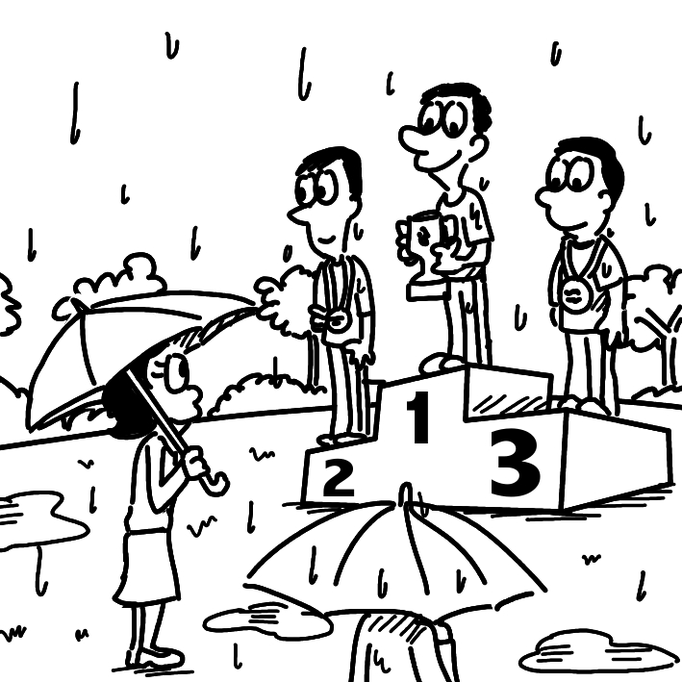
A.

(B) 1. What is TRUE about the picture? (p. 30)
(A) The stage is emitting smoke.
(B) The environment is dreary.
(C) There is high-tech equipment.
(D) Something is being outlawed.

(B) 2. What can we say about the people? (p. 26)
(A) They are facing opposition.
(B) They are taking part in a ceremony.
(C) They are wearing earphones.
(D) They are filtering the air.

For question number 3, please look at picture B.
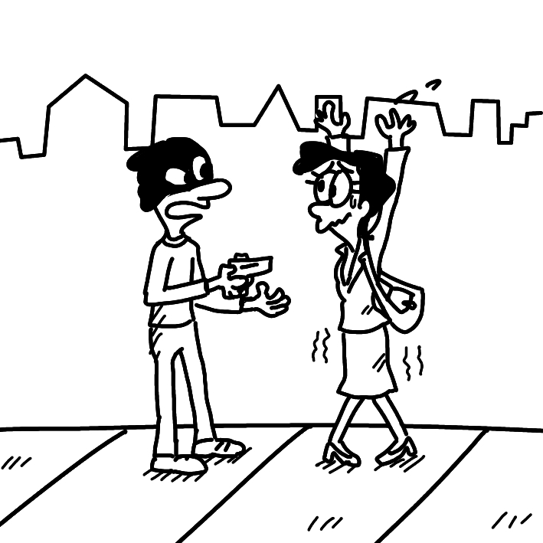
B.

(C) 3. What do we know about the man? (p. 26)
(A) He is charging at the woman.
(B) He is sprucing up the place.
(C) He is doing something illegal.
(D) He is being very heroic.

Part 2. Best Response Questions (20%)
Listen to the question or statement and choose the best response.

(C) 4. Factories in that country are known for their
humane treatment of workers. (p. 26)
(A) Agreed. There should be laws against
that.
(B) That’s true. Workers always complain
about it.
(C) I disagree. People there work in terrible
conditions.
(D) You’re right. Not everyone is treated
well.

(B) 5. What is your opinion on the slaughter of the
animals? (p. 26)
(A) I’m glad that they were saved from the
wild.
(B) They should be killed in nicer ways, if
possible.
(C) The zoos should do a better job of taking
care of them.
(D) They can be hard to raise in a normal
home.

(A) 6. This movie was a breath of fresh air for
audiences. (p. 30)
(A) I know. It was a welcome change from
the typical film.
(B) No. It was being shown in theaters, not
outdoors.
(C) That’s true. People were so scared that
they couldn’t breathe.
(D) Yeah. All the film did was copy other
popular movies.

(B) 7. Jenny decided to spruce up her apartment
over the weekend. (p. 30)
(A) I know. She doesn’t want to live there
anymore.
(B) True. She prefers things clean and
organized.
(C) Right. She didn’t spend any time at her
place.
(D) Yeah. She asked me to help her move
out.

(D) 8. Cell phone use has been outlawed during
school hours. (p. 26)
(A) Right. They are still deciding what to do.
(B) Good. Students should be allowed to use
them.

(C) Yes. The rule making them illegal has
been canceled.
(D) Yeah. Now we have to wait until after
class to use one.

Part 3. Conversation Questions (12%)
Listen to each conversation and answer the question.

(D) 9. F: How come your brother is never home?
What does he do? (p. 26)
M: He works for the government, so he has
to travel a lot.
F: I see. That must be an interesting job.
M: He even goes into dangerous countries
to talk with their leaders.
F: Then he must be important to our
country’s safety.
M: I’m proud of him. He does heroic work.
Q: What does the man think about his
brother’s work?
(A) It is less dangerous than it seems.
(B) It is careless and out of control.
(C) It is random and changes a lot.
(D) It is brave and requires courage.

(C) 10. M: I’m back from vacation. What did I
miss at work? (p. 26)
F: Well, the bosses decided to make a few
policy changes.
M: You don’t sound too happy about that.
F: It’s made things more inconvenient for
me.
M: I see. What are the opinions of our
coworkers on the changes?
F: There’s a lot of opposition to them,
that’s for sure.
Q: What is TRUE about the new changes?
(A) Almost everyone supports them.
(B) They are not final yet.
(C) Many people are against them.
(D) They are going to be canceled.

(C) 11. F: Many things could be better about this
restaurant. (p. 30)
M: Oh, really? What could be done better?
F: The service isn’t very good. The
waiters aren’t fast enough.
M: Compared to other places, I don’t think
it’s that bad.
F: And the food. I could cook tastier food.
M: You can cook? Then put your money
where your mouth is.
Q: What does the man tell the woman to
do?
(A) To stop talking about food.
(B) To leave the restaurant.
(C) To actually make some food.
(D) To not pay for the food.

Part 4. Short Talk (9%)
Listen to the passage and answer the questions.

Bullfighting is a Spanish tradition that has been around for centuries. Portugal, Southern France, and countries in South America also practice the sport. It consists of three stages, lasting twenty minutes in total. During each stage, the matador waves around a cloth, making the angry bull charge at them. They must be well trained and never lose concentration, for one mistake can lead to serious injury or even death. For this reason, men who enter the ring are celebrated. The final stage is always the killing of the bull, as the famed red cloth is brought out. This act is viewed as an artistic performance. Of course, the matador needs additional help to perform the heroic task. Bulls are fed drugs to weaken them before the event.

(B) 12. Which country is NOT said to practice
bullfighting?
(A) Portugal.
(B) Italy.
(C) France.
(D) Spain.

(A) 13. What is NOT true about the bullfight?
(A) Each stage lasts twenty minutes.
(B) There are three stages.
(C) The bull is killed in the final stage.
(D) Matadors are thought of as heroes.

(C) 14. What is said about the matadors?
(A) They always make one mistake.
(B) They can lose focus once or twice.
(C) They need help to kill the bull.
(D) They are not usually well trained.

Section Two: Reading Comprehension
一、詞彙 (15%)

(B) 1. Senior citizens now ____ a quarter of the
country’s population. (p. 26)
(A) incite (B) constitute
(C) charge (D) enrage

(D) 2. The man’s ____ actions in saving the child
from the fire were praised by everyone.
(p. 26)
(A) artistic (B) disoriented
(C) illegal (D) heroic

(A) 3. The actress made a fashion statement in
choosing to wear a suit to the award ____. (p. 26)
(A) ceremony (B) resolution
(C) construction (D) display

(A) 4. Jeff’s success ____ his use of unusual
practices in preparation. (p. 26)
(A) justified (B) situated
(C) purified (D) spruced

(B) 5. We are relieved to see strays now kept in
more ____ conditions. (p. 26)
(A) dreary (B) humane
(C) enlightened (D) allergic

二、文意選填 (14%)

If you live in a crowded city with many factories and cars, breathing clean air can be a real issue. You might think to go out and buy expensive __(6)__ devices to produce clean air. However, there is a natural, more __(7)__ solution. Introducing certain plants into the home can bring a breath of fresh air, in more ways than one.

Use three major plants. The areca palm __(8)__ carbon dioxide (CO₂) into oxygen. It should be placed in the living room. The mother-in-law’s tongue goes in the bedroom. This plant removes the CO₂ from the air and __(9)__ oxygen overnight. Lastly, the money plant is a must-have. It’s somewhat of a(n) __(10)__ in the plant world for its ability to remove harmful chemicals from the air.

An Indian pioneer used these plants to fill a 50,000 square foot business center with over 300 people. The building was __(11)__ the healthiest in the entire city. The use of plants to __(12)__ the air also enabled the center to cut down on energy costs.

(A) converts (B) filter (C) high-tech
(D) specialist (E) economical
(F) rated (G) emits

Answer: 6. (C) 7. (E) 8. (A) 9. (G)
10. (D) 11. (F) 12. (B)

三、閱讀測驗 (9%)

The annual dolphin drive hunt in Taiji, Japan takes place from September to April. Dolphin and whale hunting has been a tradition in Japan, and especially in Taiji, ever since better fishing techniques and tools were developed in the early 17th century. The term “drive” comes from the method of driving, or herding dolphins from open waters into a closed harbor area. Typically, between 1,200 and 1,800 dolphins in Taiji are slaughtered or captured and sold to aquariums each year. This number is falling due in part to opposition from outside organizations and governments. Another reason is that dolphin numbers simply decrease every year.

The people of Taiji offer various reasons behind their dolphin drive hunts. The official purpose as declared by the Japanese government is to provide food. Yet, only a small minority of Japanese actually eats dolphin meat. Further, the meat contains high levels of mercury, a harmful chemical. Another explanation for the dolphin drives is that they are just respecting tradition and Japan’s “food culture.” The Japanese are afraid that if dolphin and whale hunting is outlawed, then other Japanese fishing will be attacked as well. Finally, some local fishermen justify the hunts as pest control. They want to limit the amount of dolphins in the ocean to be able to catch more fish.

(B) 13. What is the second paragraph mainly about?
(A) When the annual dolphin drive hunt in
Japan takes place.
(B) Reasons behind the Japanese dolphin
drive hunts.
(C) Reasons against dolphin drive hunts in
Japan.
(D) Causes for the decreasing dolphin
numbers in Japan.

(D) 14. What is NOT true about Taiji’s annual
dolphin hunting?
(A) It lasts for over half a year.
(B) It has existed for about four hundred
years.
(C) It means driving dolphins from open
waters into closed areas.
(D) It offers dolphin meat that many
Japanese eat.

(C) 15. The author suggests people avoid eating
dolphin meat because ____.
(A) it is against the law
(B) it is not that tasty
(C) it contains a harmful chemical
(D) it is better to sell dolphins to aquariums

四、中譯英 (12%)

16. 新稅法已宣布於下個月開始生效。(p. 27)
It has been announced that the new tax law
will come into effect starting next month.

17. 我希望藉由深造，日後在我的生命中對社會
更有貢獻。(p. 33)
I hope that by studying further, I will be able to
contribute more to society later on in life.

18. 這支夢幻隊伍主要是由職業棒球隊員所組
成的。(p. 27)
This dream team consists mainly of players
from the professional baseball league.

