 | Weekly Review Test Jan. 2012 1/2-1/6
 | Week 1 (pp. 9-19) Advanced Level
Class:____________________________ No.:____________ Name:______________________________

Section One: Listening Comprehension
Part 1. Picture Questions (6%)
Look at each picture and answer the question.

For questions number 1 and 2, please look at picture A.
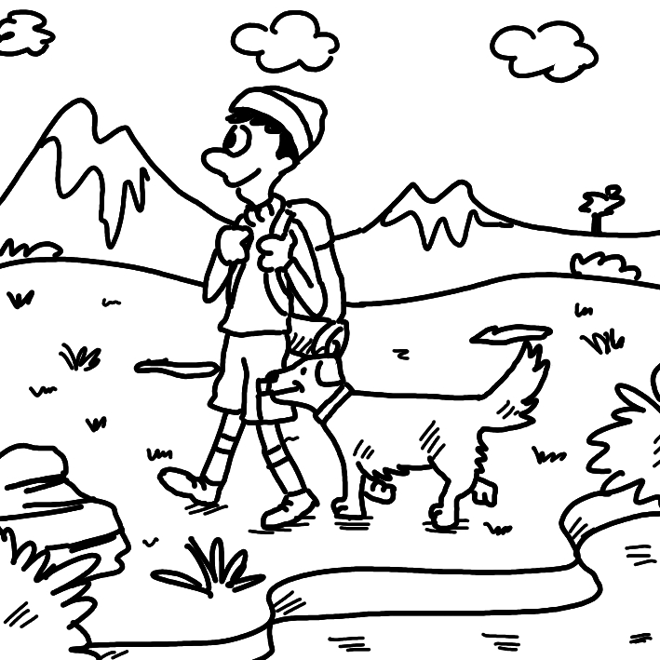
A.

(A) 1. What is TRUE about the picture? (p. 13)
(A) There is a man in the wilderness.
(B) There is an infant with the man.
(C) The man is being challenged to a duel.
(D) An explosion has hit the man.

(D) 2. What can we say about the man? (p. 13)
(A) He is fighting in hand-to-hand combat.
(B) He is overhearing other people.
(C) He is walking near a cliff.
(D) He is the sole human in the picture.

For question number 3, please look at picture B.
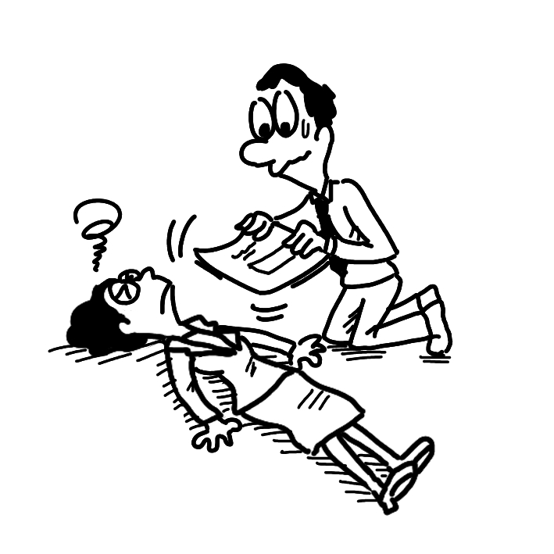
B.

(C) 3. What do we know about the woman? (p. 11)
(A) She is being kidnapped.
(B) She is bound hand and foot.
(C) She is unconscious.
(D) She is on the lam.

Part 2. Best Response Questions (20%)
Listen to the question or statement and choose the best response.

(B) 4. The news report brought the issue to the
forefront. (p. 19)
(A) Yeah. It was treated as if it wasn’t
important.
(B) I know. Now everyone’s attention is on
it.
(C) Right. The report didn’t mention it once.
(D) True. The issue was only talked about
once.

(C) 5. Frank has been on the lam for almost his
entire life. (p. 15)
(A) Really? When did he stop eating meat?
(B) That’s true. He grew up without any
friends.
(C) Yes. He has been running from the
government.
(D) I know. His father left him when he was
little.

(B) 6. The agreement between the two companies
was binding. (p. 15)
(A) Agreed. It favors one company over the
other.
(B) You’re right. There is a fine for breaking
it.
(C) I know. Neither company has signed it
yet.
(D) Yes. It was canceled and had to be
rewritten.

(A) 7. It appears that a girl was kidnapped from her
home. (p. 11)
(A) That’s terrible. Have her parents
contacted the police?
(B) Yes. She didn’t want to live there
anymore.
(C) I know. They had to sell the house.
(D) You’re right. No one wanted to buy it.

(C) 8. Can you help Aaron? He needs to find
storage. (p. 13)
(A) Sure. What does he want to buy?
(B) Of course. When did he last see it?
(C) OK. Does he have stuff he needs to put
away?
(D) Yeah. Isn’t there a gas station close by?

Part 3. Conversation Questions (12%)
Listen to each conversation and answer the question.

(C) 9. F: How are you doing in English class?
M: Not bad. I like the teacher, Mrs. Brown.
F: Oh, yeah. She’s cool. I took her class last
year. (p. 11)
M: We’re having our second test next
Wednesday.
F: I don’t remember her tests. Are they
difficult?
M: Well, in my opinion, this will be a walk
in the park.
Q: What does the man say about the test?
(A) It will require a lot of studying.
(B) It will take place in a park.
(C) It will be really easy.
(D) It will be close to impossible.

(D) 10. M: We’re going to have breakfast early
tomorrow. (p. 15)
F: I think I can make it. What time?
M: Probably around eight. Is that too early
for you?
F: Of course not. How about Bill? Will he
come?
M: No. He has been suffering from a
headache.
F: Well, he doesn’t get enough sleep and
now it’s taken a toll on him.
Q: What does the woman say about Bill?
(A) He doesn’t mind not sleeping enough.
(B) He wakes up early all the time.
(C) He won’t wake up on time.
(D) He is hurt by his lack of sleep.

(A) 11. F: I just bought a new tent. We can go
camping now. (p. 13)
M: Great. I’ve done some research and
picked out a good site.
F: OK. How does next weekend sound to
you?
M: That won’t be a problem. I’ll clear out
my schedule.
F: Is there anything we’ll have to worry
about on the trip?
M: Yeah. We will have to ward off the wild
animals out there.
Q: What does the man talk about?
(A) Chasing away wild animals.
(B) Hunting wild animals.
(C) Feeding wild animals.
(D) Studying wild animals.

Part 4. Short Talk (9%)
Listen to the passage and answer the questions.

Last year, President Obama signed executive orders weaving cyber combat into the American war strategy. This was necessary in light of the growing conflict on the virtual battlefield between countries such as China, Russia, and the U.S. Even France has been accused of cyber-spying on the U.S. The truth is that the world runs on the flow of information. The Internet is the fastest and most efficient way to spread that information. However, using the Web is also dangerous since anyone can access it. Therefore, it is up to each country’s government to protect all the data that is stored online. Companies must defend themselves as well. For example, Google claimed that China tried to steal Gmail passwords recently.

(D) 12. Which country is NOT mentioned as a
participant in the cyber war?
(A) Russia.
(B) America.
(C) France.
(D) Korea.

(B) 13. According to the talk, why is it dangerous
to use the Internet?
(A) Information spreads fast.
(B) Anyone can use it.
(C) There is a lot of data.
(D) It’s not very efficient.

(B) 14. What is said about companies like Google?
(A) They need the government’s help.
(B) They need to protect themselves.
(C) They try to steal information, too.
(D) They aren’t attacked as much.

Section Two: Reading Comprehension
一、詞彙 (15%)

(C) 1. This room is for ____. We put things in here
that we seldom use. (p. 13)
(A) wilderness (B) assassination
(C) storage (D) capability

(A) 2. Advertising tries to ____ people to buy a
particular product or service. (p. 13)
(A) convince (B) demand
(C) overhear (D) challenge

(A) 3. “How dare you ____ me of lying!” said
Samantha furiously. (p. 13)
(A) accuse (B) declare
(C) demand (D) prosecute

(A) 4. The soldiers trained for ____ every day,
never knowing when the war would start.
(p. 18)
(A) combat (B) explosion
(C) hideout (D) agency

(D) 5. The heart is a(n) ____ organ that we cannot
survive without. (p. 18)
(A) harsh (B) executive
(C) binding (D) vital

二、綜合測驗 (14%)

David Balfour is only 17 when his parents pass away. His life in Scotland is no __(6)__ in the park, but David finds out that his uncle owns an estate. He immediately __(7)__ to see Ebenezer Balfour. His uncle is unfriendly, despite David’s best efforts to be cordial. He takes David to meet a friend, Captain Hoseason of the Covenant. Hoseason invites David onto the ship, __(8)__ David is knocked unconscious.

David wakes up to find himself __(9)__, as the ship has sailed off toward America. Apparently, he is to become a servant in Carolina. __(10)__, Hoseason forces him to be a cabin boy. David meets another prisoner, Alan Stewart. They work together to force themselves off the Covenant and back to Scotland. Unfortunately, the two are separated in the process, and David is left __(11)__ for himself in the wilderness. Finally __(12)__ Alan’s homeland of Appin, David hopes that his troubles are over.

(B) 6. (A) picnic (B) walk
(C) hiking (D) pie

(B) 7. (A) sets aside (B) sets off
(C) sets down (D) sets by

(D) 8. (A) which (B) that
(C) what (D) where

(D) 9. (A) free and easy (B) on the run
(C) as sly as a fox (D) bound hand and foot
(B) 10. (A) In particular (B) In the meantime
(C) For one thing (D) On the other hand

(D) 11. (A) fend (B) with fending
(C) fended (D) to fend

(C) 12. (A) to reach (B) reached
(C) reaching (D) he reached

三、閱讀測驗 (9%)

Kidnapped is an adventure novel by Robert Louis Stevenson, first published in Young Folks magazine in 1886. It is considered historical fiction; much of the story is based on real events that occurred in 18th-century Scotland. In fact, many characters, and one of the major ones, Alan Stewart, were real people. The major family in the story, the Balfours, shares the same last name as Stevenson’s mother. Though Stevenson never publicly stated what parts of the story matched true events, he was well known as a passionate reader of legal history. Thus, the earliest reviews thought that the novel was Stevenson’s version of the life of James Annesley, an heir who was kidnapped at the age of 12 and sent from Ireland to America by his uncle Richard. Thirteen years later in 1741, James escaped and returned to Ireland to reclaim his right to the estate.

Apart from the book’s retelling of historical events, Stevenson’s novel can also be regarded as a simple “boy’s novel,” a story of a boy’s journey as he becomes a man. Because of this, Kidnapped did not receive total approval. Some gave it unfavorable reviews, declaring the story was too simple, lacking plot development. Nevertheless, the novel still retains its popular appeal today.

(C) 13. Kidnapped may be regarded as each of the
following EXCEPT ____.
(A) an adventure story
(B) a historical fiction
(C) a romantic tale
(D) a boy’s novel

(D) 14. What does the second paragraph chiefly
deal with?
(A) The plot structure of Kidnapped.
(B) The main characters of Kidnapped.
(C) The influence of Kidnapped on later
writers.
(D) Opposing reviews of Kidnapped.

(A) 15. What is NOT true about Kidnapped?
(A) It was first published in the 18th
century.
(B) Much of its plot is based on real events
and people.
(C) The author was highly interested in
legal history.
(D) Its hero has a long journey back to his
homeland.

四、中譯英 (12%)

16. 不要忘了掛蚊帳以趕走蟲子。(p. 13)
Don’t forget to put up a mosquito net to ward off bugs.

17. 長工時折損了凱特的健康，她只做了兩個月
就累壞了。(p. 15)
Long working hours took a toll on Kate’s health and she got burned out after only two months.

18. 另一個學生不承認自己的過錯，反而怪罪於
我。(p. 19)
The other student didn’t admit his mistakes.
Instead, he put the blame on me.

